**Python projects**

**1️. Password Generator**

**Code and output:**

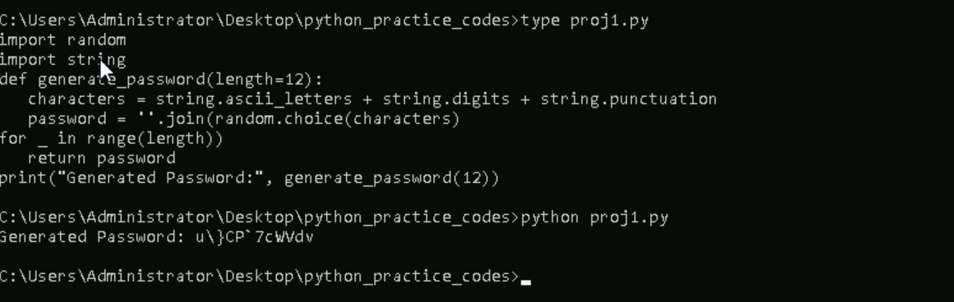

**2️. To-Do List (CLI)**

**Code and output:**

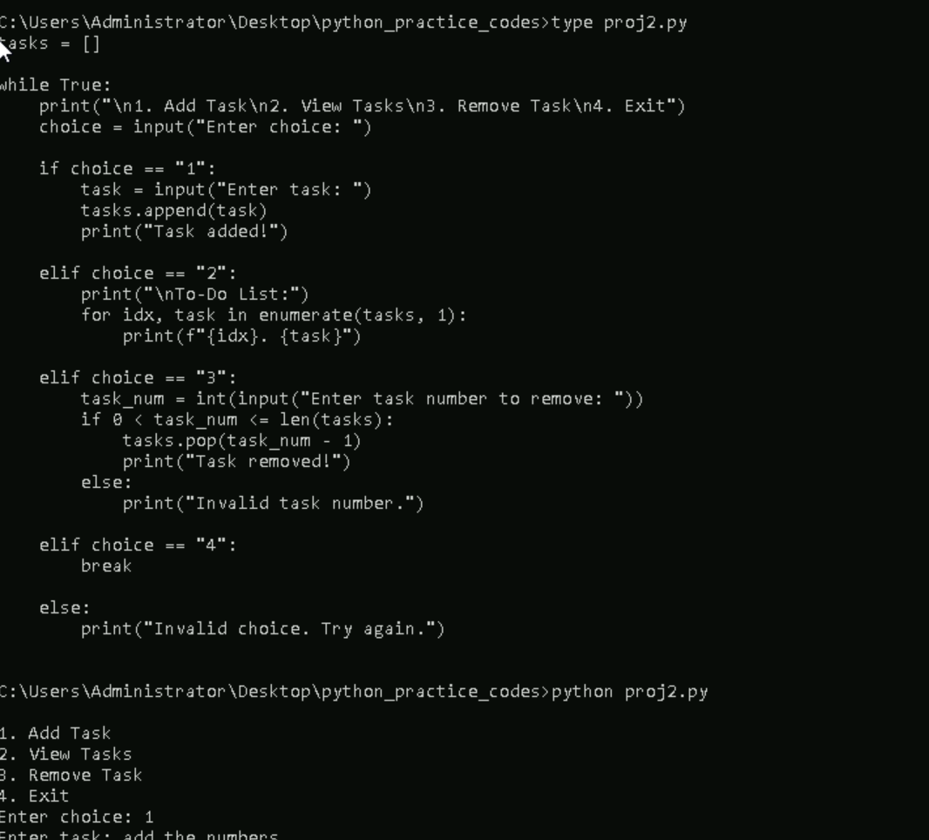

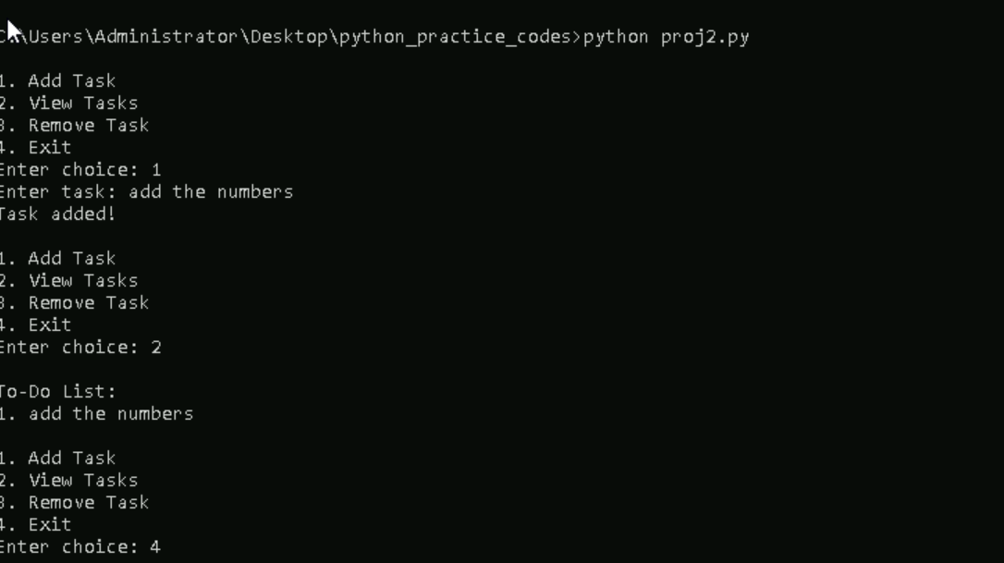

**3. Number Guessing Game**

**Code and output:**

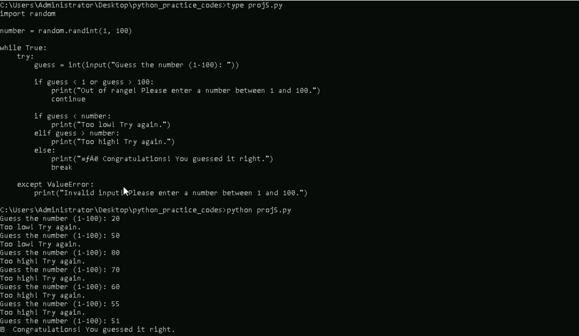

**4. Weather App (API-based)**

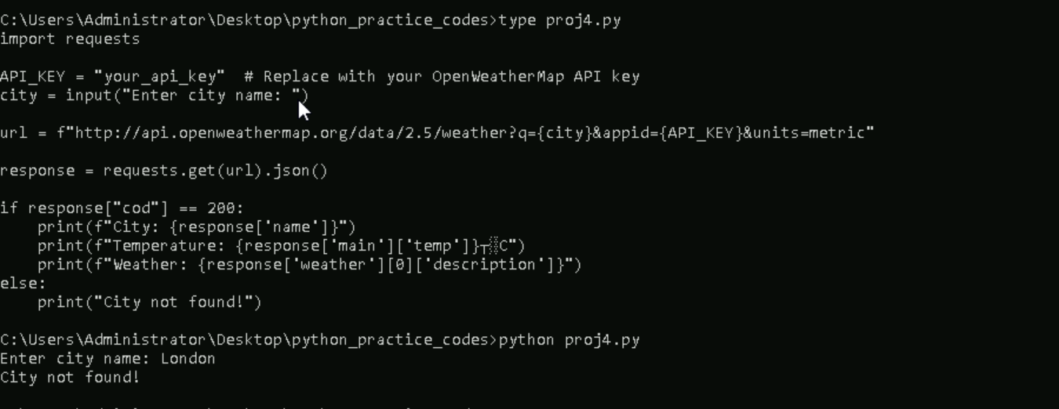

**5.qr code generator**

**Code and output:**